Making PDFs Accessible
  - Alternative Text Office
  - Disability Resource Center
  - University of Georgia

*PDF = Portable Document Format. Most PDFs are images. Hence, why, there is so much work to be do to make them accessible unless they were created with accessibility in mind.

Before you, make the PDF accessible, check to see if it is already accessible. If you can highlight words in the PDF or copy and paste the words into another program, it is accessible. If you try to highlight a PDF and a big blue box appears, it is not accessible.

How to Change Page Numbers

- Open PDF
- Click on Page Thumbnails on the left hand side of document 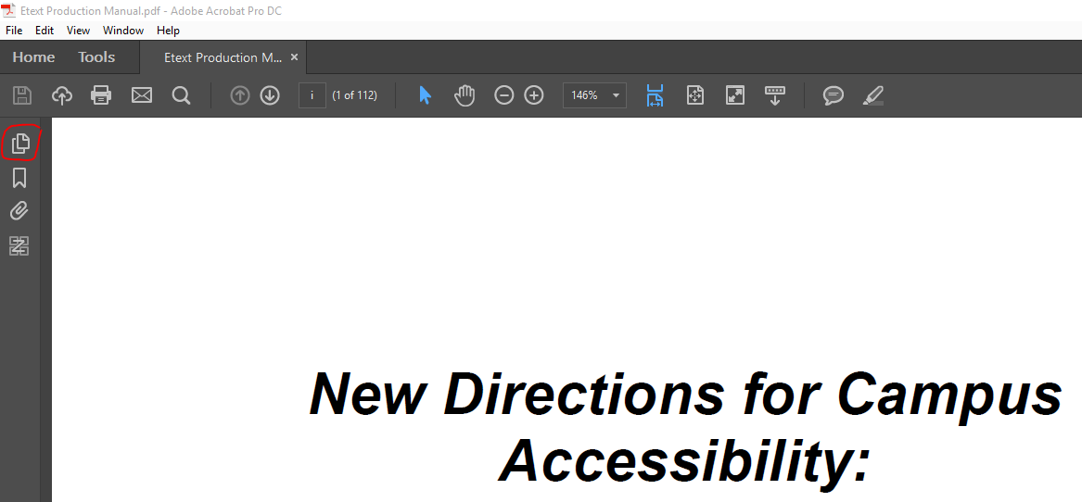

- Little images of the pages will appear as so:
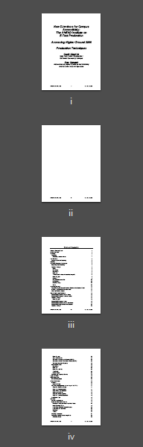

- Right Click any of the page thumbnails

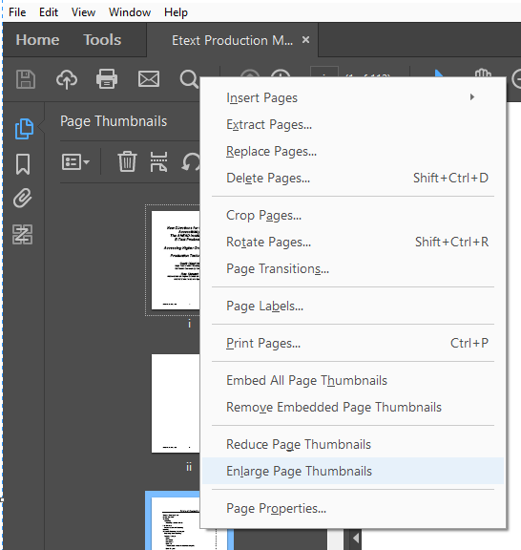

- Select page labels, a new screen will appear:

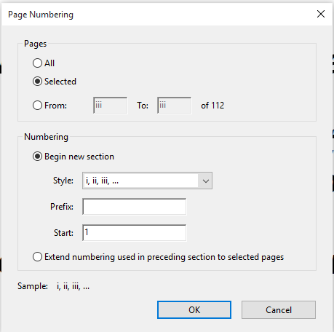

- Select the page range and style of numbering the original document uses.
  - Prefixes are usually used at the end of the books such as G-1 for Glossary & I-1 for Index, etc
  - Roman numerals are used for the front matter of books (table of contents, acknowledgements, preface, etc)
  - Everything needs to match exactly to the original document

- Hit “ok” when finished, and check for accuracy.

Bookmarking a PDF

- Open PDF
- Click on Bookmarks, under the Page Thumbnails:

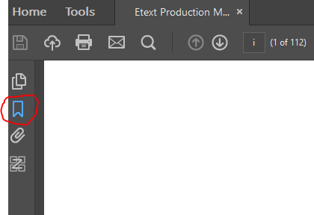

- The Bookmarks may be empty, filled with mumbo-jumbo, or perfectly fine.
- If they are empty, Right click the top of the PDF page, and select “Add Bookmark” (second option) 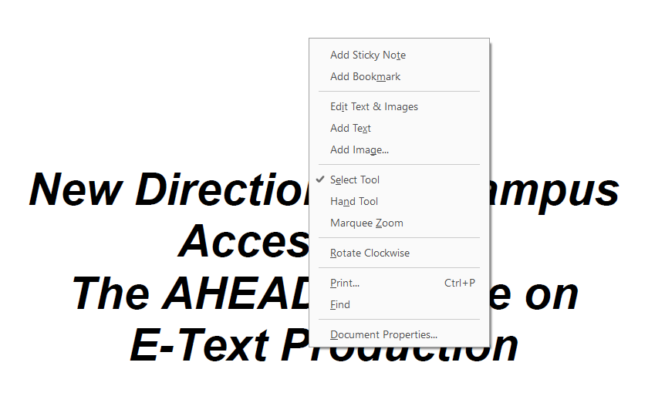

- When adding a bookmark, it will appear as “untitled” in the bookmark section:

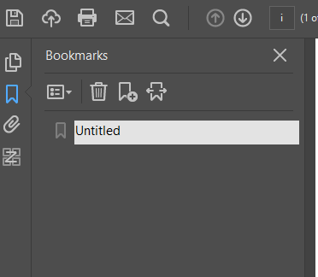

- You can either edit this as you go, or make all the bookmarks at once and then rename them later. To rename the bookmark, right click on the “Untitled” Bookmark and select “Rename”

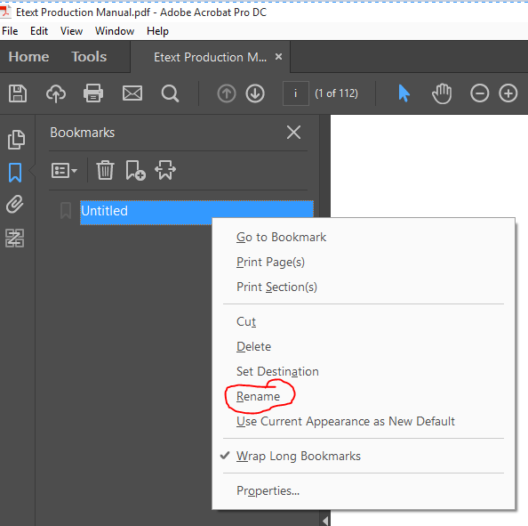

- General Rules for Renaming: If it is listed in the Table of contents, it needs to be bookmarked.
  - Some books have a table of contents and an expanded table of contents; use the smaller table of contents. We will go over the search feature in the next section.
  - The easiest way to do this is to refer back to the table of contents and input the page numbers in which each section/chapter starts, hence why we did the page numbers first.
  - If the document is large, you can use abbreviations in the bookmarks such as “Ch” for Chapter, “&” for and, etc. Making a document accessible increases the size of the document, so be wary of any upload limits your platform may have.

- Most important: Save, Save, Save all of your hard work. This is an excellent stopping point before moving on to the next section.

OCRing PDF for accessibility

*OCR = optical character recognition. This simply means that the program takes the image and converts it to text.

- Open PDF using Adobe Acrobat DC
- Click on Tools
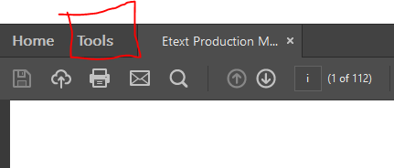

- Locate Action Wizard under Customize, at the very bottom of the Tools page.

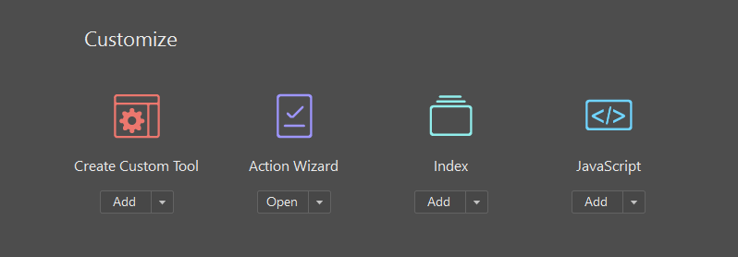

- Click on the arrow next to add, select open Action Wizard

- Action list on right hand side will open. Select “Make Accessible”

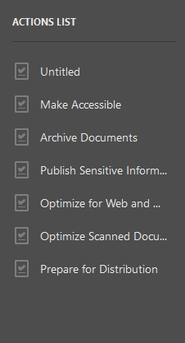

- Click “Start”

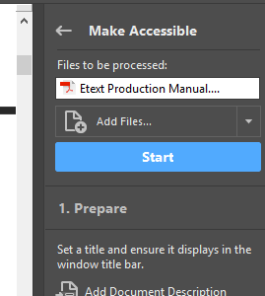

- A Description box will appear, prompting you to input the correct information:

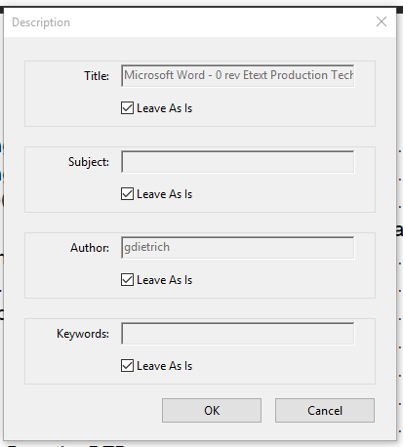

The boxes appear to be greyed out, but to fix this, just uncheck the “Leave AS IS” boxes under each section:

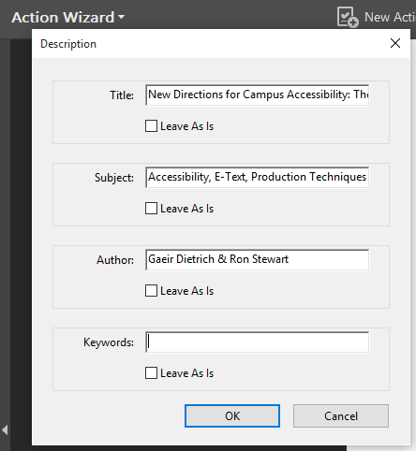

Hit “OK”
- “Recognize Text – General Settings” Box appears next:
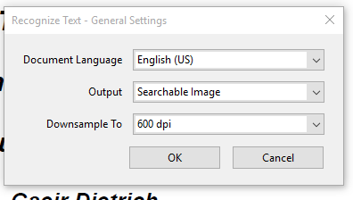

  - Document language: The language the document is in. If the document is in multiple languages, contact the alt media office for help as we have special software (ABBYY) that will let us process documents in multiple languages

  - Output: Always select “Editable Text and Images” This allows the student to modify the document in any way the need to enhance their learning experience.

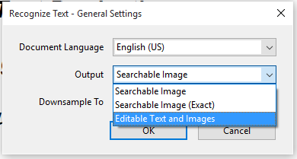

  - Downsample to: Leave at 600 dpi (dots per inch). This is the standard.

  - Hit “OK”

- The conversion starts to happen and a box will appear on the bottom right of the screen to show progress of how the conversion process is going:
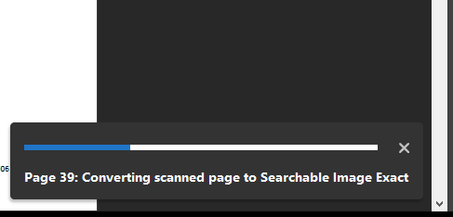

  - Depending on the size of the PDF, depends on how quickly this process goes. Anything less than 600 pages should be fine, provided you have enough space on your device.

- Fillable form box appears:

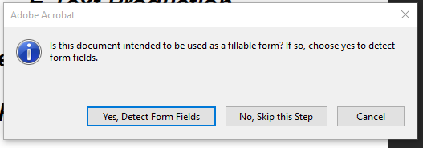

Select No unless it is a fillable form.

  - Note: Fillable form wizard often misses some form fields if created in another program. You’ll need to use an additional tool to make forms fillable.

- Set Reading Language box appears:

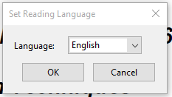

This is Adobe’s way of checking their work. Hit “OK”
- Page pass process is the quickest process, so quick I couldn’t take a screenshot of it but it looks identical to the conversion process. It states “ Pages Passed” instead.

- Set Alternative Text Boxes appears

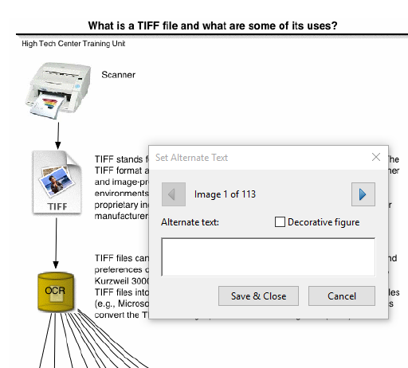

  - Depending on how many images are in the document, depends on how many of these dialogue boxes you need to go through. If the image is decorative, such as the logo for Taylor & Frances, you can click on the “Decorative Figure” box, as the publisher is stated in actual text in the book.
  - The goal of alternative text in PDFs is to state exactly what is shown without personal bias. For example this image I would state as: Scanner with arrow leading to a paper with a photo on it labeled TIFF, which leads to a cylinder labeled OCR, with nine arrows leading to nine images of papers labeled as: KES, MP3, E Book, HTML, ARK, ASCII, Word Docs, PDF, RTF, and DXP.
  - If images are complicated/hard to explain, please contact the Alternative Text office as we can provide guidelines on this process.
  - Once done setting the Alternative text, select “save & close”

- Accessibility Checker Options box:
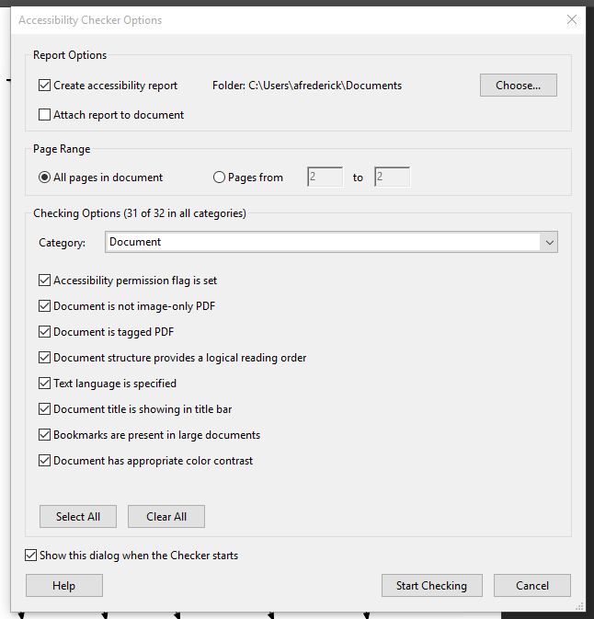

Select”Start Checking”

- Accessibility Checker Results are posted on the left side of the screen with any accessibility issues the PDF has:

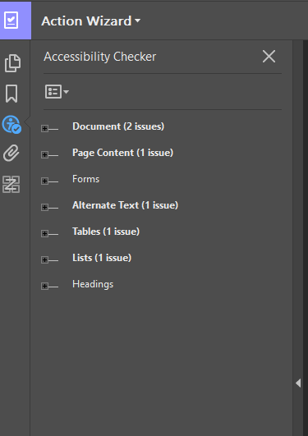

You can click on the plus signs to expand the checks as so:

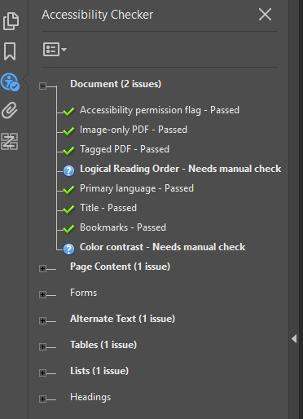

For anything you’re not sure about, you can right click for a list of options:

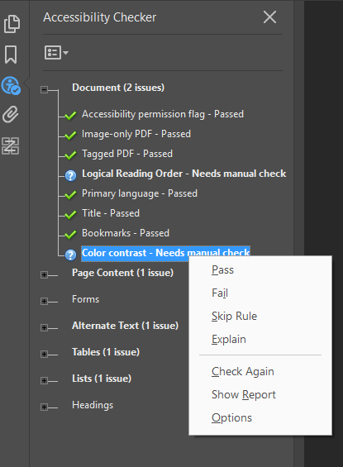

Explain will take you to the Adobe website to help you solve that issue.

- Congratulations, your PDF is now accessible! Please save your work.

