Accessible Word Documents

Use Headings

Using good heading structure helps people without eyesight to understand how the document is organized. Screen reader and Braille users can also jump between headings, which makes navigation much more efficient than if there are no headings.

Making text larger and bold does not make it a heading. In order to convert text to a heading in Microsoft Word, you must use the built-in Heading styles like “Heading 1” and “Heading 2”, available under Styles in the Home tab.

Headings should form an outline, using the “Heading 1” style for the main heading, and “Heading 2” for sub-headings. If there are additional levels of headings within the document’s outline, using “Heading 3”, “Heading 4”, etc.

Watch Microsoft Video on using Headings

Use Lists

Create lists using Word’s built-in tools for ordered (numbered) and unordered (bulleted) lists. Without using these tools, a list is not really a list, which makes the content more difficult for screen reader users to understand.

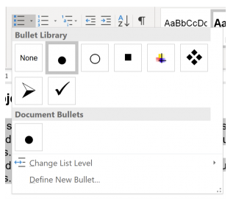

Use Meaningful Hyperlinks

Adding meaningful hyperlinks in Word is simple. Include language in your document that conveys relevant information about the destination of the link, highlight that text and right click and select Hyperlink. Include the URL in the Address field and select OK.

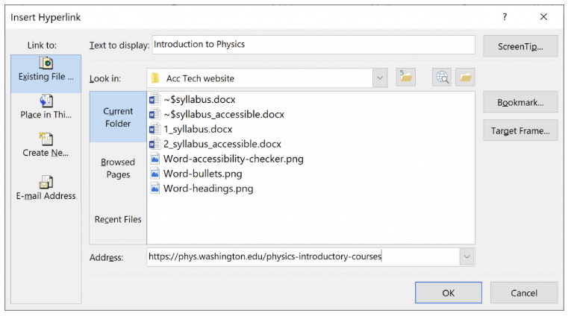

Watch Microsoft’s video on creating accessible links

Add Alternative Text for Images

In most versions of Word, you can enter alternate text by right clicking an image and selecting Format Picture. Within the Format Picture dialog, Layout & Properties (3rd option) select Alt Text and enter the title and the Description field.

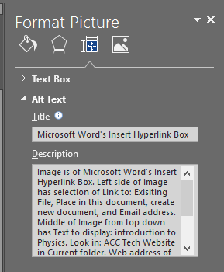

Use Tables

Word has limitations when it comes to making tables accessible. Tables can be very difficult for screen reader users to understand unless they include markup that explicitly defines the relationships between all the parts (e.g., headers and data cells). For a simple table with one row of column headers and no nested rows or columns, Word is up to the task. However, tables that are more complex made accessible only with HTML or Adobe PDF (accessible table markup can be added to the PDF using Adobe Acrobat Pro).

Often complex tables are simplified by breaking them into multiple simple tables with a heading above each.

For simple tables, the only step necessary for accessibility is to identify which row contains the column headers. To do this in Word, select that row (Table > Select > Row), then right click the row and select “Table Properties”. This brings up the Table Properties dialog. In this dialog, click the Row tab, and check the checkbox that says “Repeat as header row at the top of each page”.

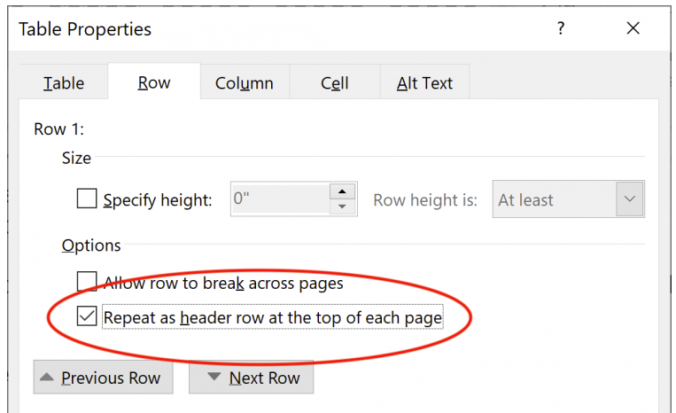

In addition, when creating a table two new tabs will appear in the ribbon. Selecting the Design tab will reveal the Table Styles Option group where you can define your Header Row.

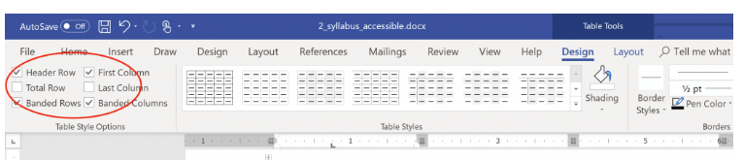

Watch Microsoft’s video on creating accessible tables

Use Accessibility Checker

Microsoft products have a built-in accessibility checker, which can help the document author test the overall accessibility of the document. The checker provides Inspection Results, feedback about the importance of each item, and tips on how to repair issues.

To do this, Save the file, click on File, Click on “Check for issues/Inspect Document” (2nd Option).

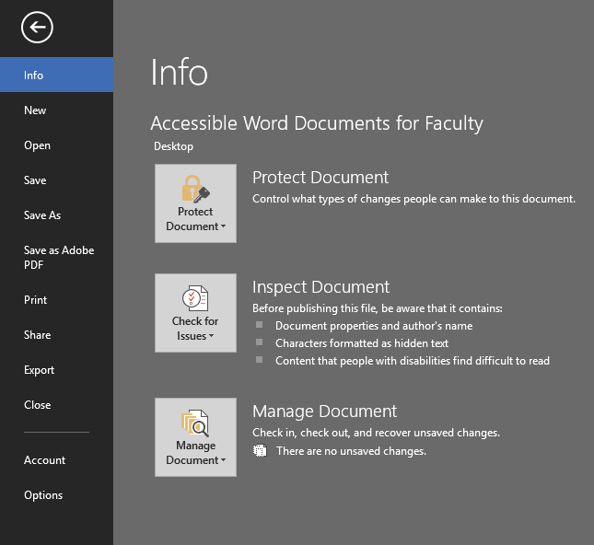

Click on “Check Accessibility”.

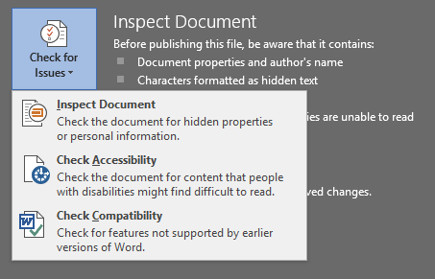

Accessibility Checker will appear in the right side of the screen as so:

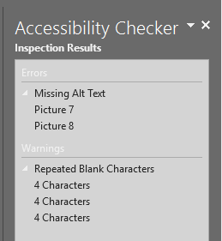

You can click on each individual issue, and instructions on how to fix it are below the results, under “Additional Information”.

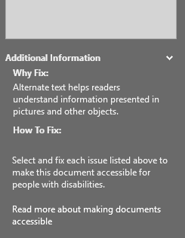

If you want to save the word document as a PDF, got to “File”, “Save as PDF”.

Doing accessibility measures in Word will make other documents (such as PDFs) accessible without any additional work.

It may seem like a lot to do, but after enough time and practice, it becomes second nature – says the specialist who has been doing this for 5 years.

If you have any questions, please contact the Alternative Text office at altmedia@uga.edu

